Name : S.Akiarasi
Reg no: 192512426
Ex. No. 2: Implementing TDMA Slot Allocation in GSM
AIM: To implement TDMA (Time Division Multiple Access) slot allocation in GSM using MATLAB and analyze system performance in terms of time slot duration, frame utilization, and number of allocated slots.
Objective:
1. To calculate the Time Slot Duration in a GSM TDMA frame by dividing the total frame time into equal time slots. This helps in understanding the time structure of GSM communication.
2. To determine the Frame Utilization (%) based on the number of allocated time slots compared to total available slots. This evaluates the efficiency of TDMA resource usage.
3. To compute the Number of Allocated Time Slots for multiple users in the GSM system. This ensures proper scheduling and interference-free communication.
Procedure:
clc; clear; close all;
FrameTime = 4.615;
Slots = 8;
SlotDuration = FrameTime/Slots;
t = 0:SlotDuration:FrameTime;
figure
subplot(2,1,1)
stem(t,ones(size(t)),'filled')
title('TDMA Time Slot Structure')
xlabel('Time (ms)')
ylabel('Slot Level')
grid on
subplot(2,1,2)
plot(t,ones(size(t)),'-o','LineWidth',1.5)
title('Continuous View of Slot Allocation')
xlabel('Time (ms)')
ylabel('Slot Presence')
grid on
Output:
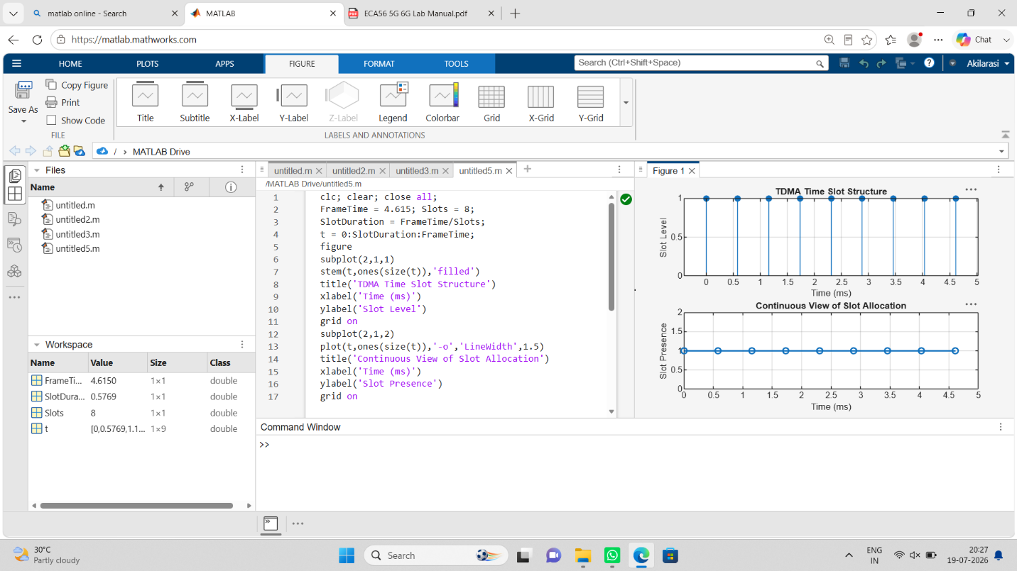

Objective 2:
clc; clear; close all;
TotalSlots = 8;
AllocatedSlots = 6;
FreeSlots = TotalSlots - AllocatedSlots;
Utilization = (AllocatedSlots/TotalSlots)*100;
disp('Frame Utilization (%)')
disp(Utilization)
figure
% Graph 1: Simple Line Plot (SAFE - no bar function)
subplot(2,1,1)
plot([1 2],[AllocatedSlots FreeSlots],'-o','LineWidth',2)
title('GSM Frame Utilization (Allocated vs Free)')
xlabel('Slot Type Index (1=Allocated, 2=Free)')
ylabel('Number of Slots')
grid on
% Graph 2: Pie Chart (SAFE)
subplot(2,1,2)
pie([AllocatedSlots FreeSlots])
title('Slot Distribution in GSM Frame')
legend('Allocated','Free')
Output:
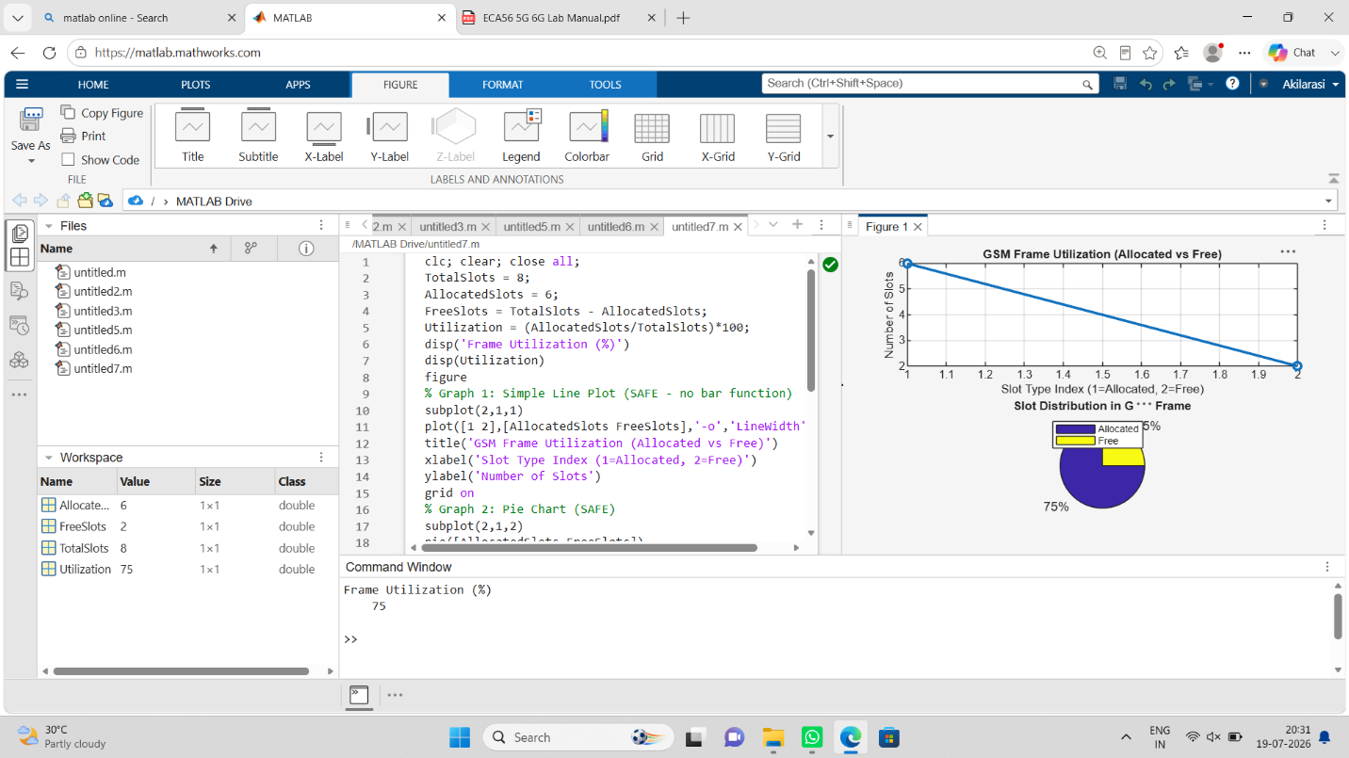

Objective 3:
clc; clear; close all;
Users = 1:8;
TotalSlots = 5;
Alloc = zeros(1,8); % Total users % Available slots % Initialize allocation
Alloc(1:TotalSlots) = 1; % Assign slots to first users
Blocked = 1 - Alloc; % Remaining users blocked
disp('User Wise Slot Allocation')
disp(table(Users',Alloc','VariableNames',{'User','Status(1=Allocated,0=Blocked)'}))
figure
% Graph 1: Allocation per user
subplot(2,1,1)
stem(Users,Alloc,'filled','LineWidth',2)
title('TDMA Slot Allocation per User')
xlabel('User Index')
ylabel('Slot Status (1=Allocated, 0=Blocked)')
ylim([-0.2 1.2])
grid on
% Graph 2: System view (safe alternative to bar)
subplot(2,1,2)
plot(Users,Alloc,'-o','LineWidth',2)
hold on
plot(Users,Blocked,'-s','LineWidth',2)
title('TDMA Slot Utilization Analysis')
xlabel('User Index')
ylabel('Status')
legend('Allocated','Blocked')
grid on
Output:
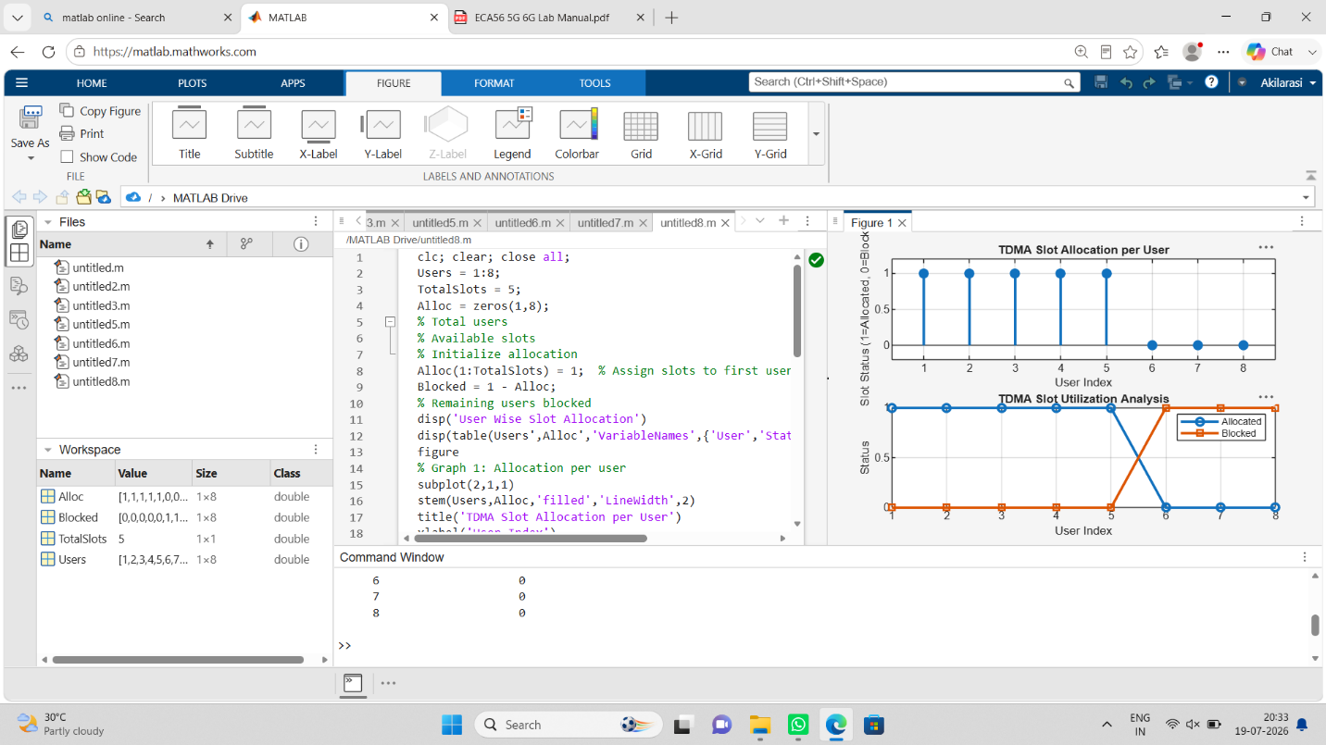

Result:
1. The time slot duration in the GSM TDMA frame was successfully calculated, confirming equal division of the frame into fixed time intervals.
2. The frame utilization was effectively analyzed, showing the proportion of allocated and free slots in the TDMA system.
3. The slot allocation per user was successfully implemented, demonstrating that limited slots are assigned to users while excess users are blocked due to resource constraints.

